**VIEW TASK PAGE**

**OVERVIEW**

A View Task Page is a web page designed to help users manage their tasks effectively. It displays a list of tasks for a user or a team and provides functions for creating, updating, and deleting tasks. The page offers an intuitive and user-friendly interface that makes it easy for users to manage their tasks in one central location

**PROBLEM STATEMENT**

The main problem that a View Task Page aims to solve is task management. Many individuals and teams struggle with managing their tasks effectively. They often use email or paper-based systems, which can be inefficient and prone to errors. Additionally, it can be challenging to keep track of tasks when working on multiple projects or with a team. A View Task Page offers a digital solution that provides a centralized location to manage tasks, making it easier for users to stay organized and productive.

**SOLUTIONS OF A VIEW TASK PAGE**

1.Task List: A list of all tasks created by the user or team.

2.Create Task: A form that allows users to create new tasks and assign them to specific projects or team members.

3.Update Task: An editing feature that allows users to modify task details such as due dates, priority, and status.

4.Delete Task: A feature that enables users to delete completed or unnecessary tasks.

5.Search and Filter: A search bar that enables users to search for specific tasks by keywords, and a filter option that allows users to sort tasks by various criteria such as due date, project, or team member.

**UML DIAGRAM**

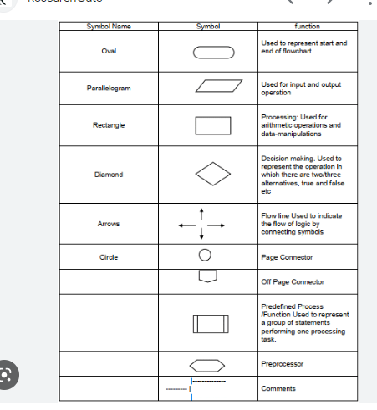

CLASS ATTRIBUTES AND METHODS

TASK COMPONENTS

VIEW TASK PAGE

TASK FORM COMPONENTS

CLASS ATTRIBUTES AND METHODS

CLASS NAME

CLASS ATTRIBUTES AND METHODS

CLASS NAME

CLASS NAME